

|  |  |  |  |  |  |  |  |  |
| --- | --- | --- | --- | --- | --- | --- | --- | --- |
|  | | | | | | | | |
|  | | DB LAB 03 | | | | |  | |
|  |  | | | | | | |  |
|  | | | |  |  | | | |
|  | | | | Basil Ali Khan(20K-0477) |  | | | |
|  | | | | 12 September 2022—Database and Management System Lab—Sir Ahmed Budhi |  | | | |
|  | | |  | | |  | | |

**SCENARIO#01:**

**Step 01:**

CREATE TABLE Faculty

(Faculty_id NUMBER(6) NOT NULL,

Last_Name VARCHAR2(15) NOT NULL,

First_Name VARCHAR2(15) NOT NULL,

Dept CHAR(3),

CONSTRAINTS faculty_pk PRIMARY KEY(Faculty_Id));

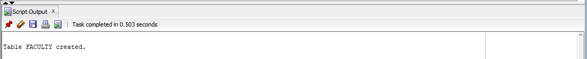

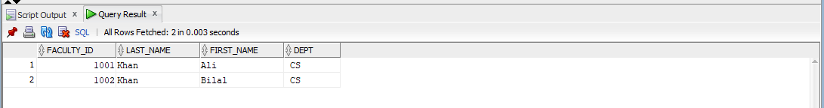

**Step 02:**

CREATE TABLE Department

(Dept_code CHAR(3) NOT NULL,

Dept_Name VARCHAR2(20) NOT NULL,

CONSTRAINT dept_pk PRIMARY KEY (Dept_code));

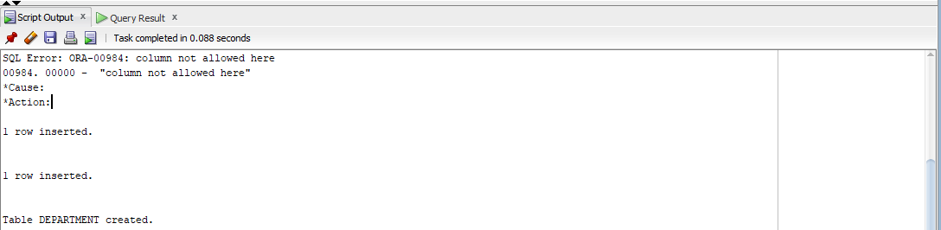

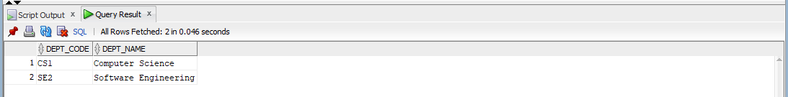

**Step 03:**

ALTER TABLE Department

ADD Location CHAR(7);

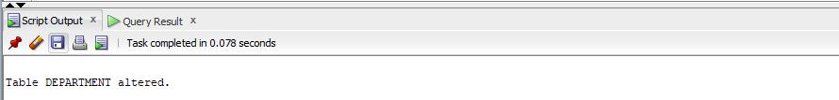

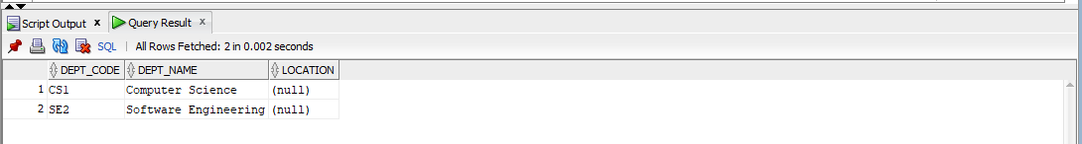

**Step 04:**

ALTER TABLE Faculty

ADD CONSTRAINT faculty_dept_fk FOREIGN KEY (DEPT) REFERENCES Department(DEPT_CODE);

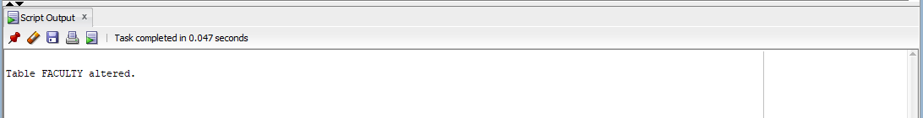

**Step 05:**

ALTER TABLE Faculty

MODIFY Last_Name CHAR(25);

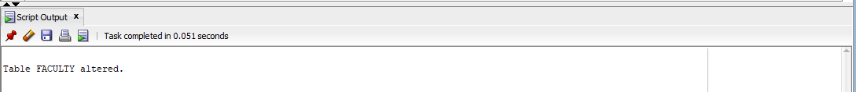

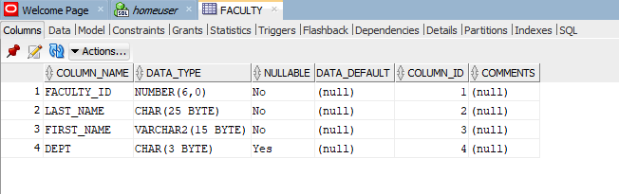

SCENARIO#02:

(1)

CREATE TABLE BOOK

(book_Id NUMBER(8) NOT NULL PRIMARY KEY,

Title VARCHAR2(15) NOT NULL,

Publisher_Name VARCHAR(15) NOT NULL);

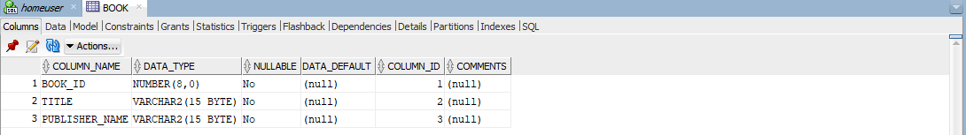

(2)

CREATE TABLE BOOK_AUTHORS

(Book_Id NUMBER(8) NOT NULL,

Author_Name VARCHAR2(15) NOT NULL,

CONSTRAINTS pk_bidlname PRIMARY KEY (Book_Id, Author_Name));

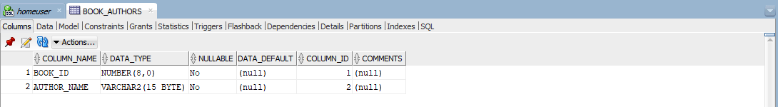

(3)

CREATE TABLE PUBLISHER

(Name VARCHAR2(15) NOT NULL PRIMARY KEY,

Address VARCHAR2(20) NOT NULL,

Phone NUMBER(11) NOT NULL);

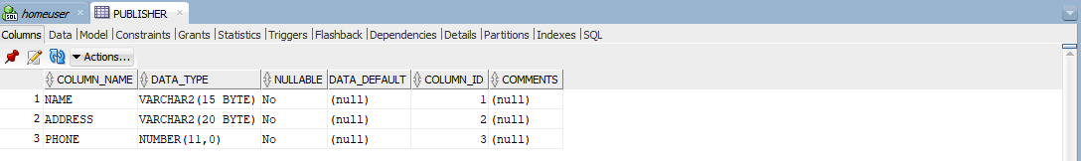

(4)

CREATE TABLE BOOK_COPIES

(Book_Id NUMBER(8) NOT NULL,

Branch_Id NUMBER(10) NOT NULL,

No_Of_Copies NUMBER(5) NOT NULL,

CONSTRAINTS pk_boidbrid PRIMARY KEY(Book_Id, Branch_Id));

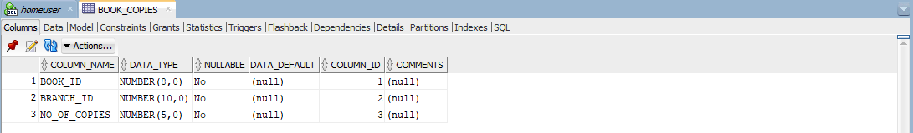

(5)

CREATE TABLE BOOK_LOANS

(Book_Id NUMBER(8) NOT NULL,

Branch_Id NUMBER(10) NOT NULL,

Card_No NUMBER(6) NOT NULL,

Date_out DATE DEFAULT SYSDATE,

Due_Date DATE DEFAULT SYSDATE,

CONSTRAINTS pk_boidbridcn PRIMARY KEY(Book_Id, Branch_Id, Card_No));

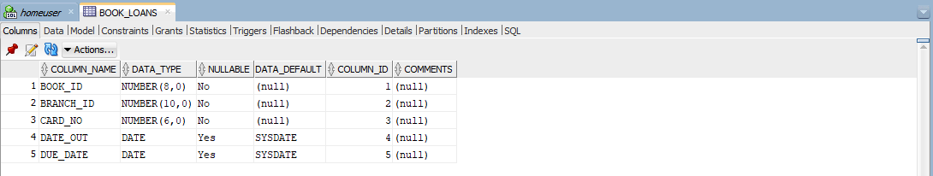

(6)

CREATE TABLE LIBRARY_BRANCH

(Branch_Id NUMBER(10) NOT NULL PRIMARY KEY,

Branch_Name VARCHAR(15) NOT NULL,

Address VARCHAR(20) NOT NULL);

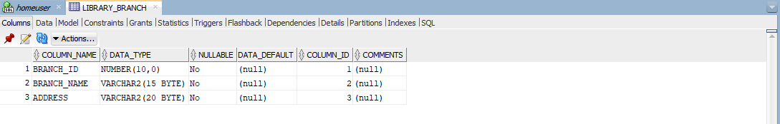

(7)

CREATE TABLE BORROWER

(Card_No NUMBER(6) NOT NULL PRIMARY KEY,

Name VARCHAR2(15) NOT NULL,

Address VARCHAR2(20) NOT NULL,

Phone NUMBER(11) NOT NULL);

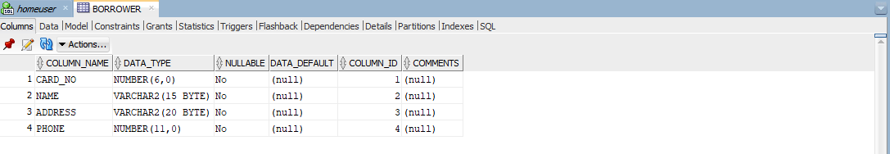

(8)

ALTER TABLE BOOK_AUTHORS

ADD FOREIGN KEY (Book_Id) REFERENCES BOOK(Book_Id);

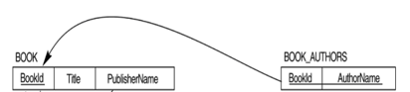

(9)

ALTER TABLE BOOK

ADD FOREIGN KEY (Publisher_Name) REFERENCES PUBLISHER(Name);

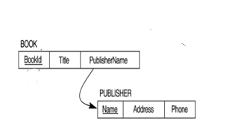

(10)

ALTER TABLE BOOK_COPIES

ADD FOREIGN KEY (Book_Id) REFERENCES BOOK(Book_Id);

ALTER TABLE BOOK_COPIES

ADD FOREIGN KEY (Branch_Id) REFERENCES LIBRARY_BRANCH(Branch_Id);

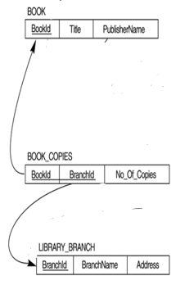

(11)

ALTER TABLE BOOK_LOANS

ADD FOREIGN KEY (Book_Id) REFERENCES BOOK(Book_id);

ALTER TABLE BOOK_LOANS

ADD FOREIGN KEY (Branch_Id) REFERENCES LIBRARY_BRANCH(Branch_Id);

ALTER TABLE BOOK_LOANS

ADD FOREIGN KEY (Card_No) REFERENCES BORROWER(Card_No);

